**YR11 Physics**

WILLETTON SENIOR HIGH SCHOOL /37marks

### WAVES TEST – 2017

Student. name: _________________________

Teacher (Please tick one box)

Dr Pitts □ Group 1

□ Group 2

Mr Dopson □ Group 1

□ Group 2

Mr Boughton □

□



**NOTE:**

1. Calculations must show **clear working** with **formulae** and final answers stated to **three significant figures.**

2. Marks will be allocated for clear and logical setting out.

3. State assumptions if working on open ended type questions.

4. Underline your answers.

5. Half a mark may be taken off for incorrect number of significant figures and incorrect units in the final answer.

1. Name the properties of sound waves which is associated with each of the following phenomenon:

a) An opera singer breaking a glass by singing. ______________________ (1)

b) Hearing around corners. ______________________________________ (1)

1. State the two conditions necessary to hear beats.

* ________________________________________________________________

________________________________________________________________(1)

* ________________________________________________________________

________________________________________________________________(1)

1. (5 marks) A speaker from a signal generator is attached to one end of a plastic tube that contains sawdust. Before the signal generator is switched on, the sawdust is distributed evenly over the length of the tube. When the signal generator is switched on and the frequency is adjusted and resonance is heard, the sawdust gathered into three piles as shown in the diagram.



1. On the diagram above, draw the standing wave pattern in the tube at this frequency. (1)
2. If the tube is one metre long, what is the frequency of the signal generator? (2)

c) What is the fundamental frequency of this tube? (2)

1. (6 marks)

A water wave, shown in the diagram below, is travelling to the right. It has a speed of 5.00 m s-1.

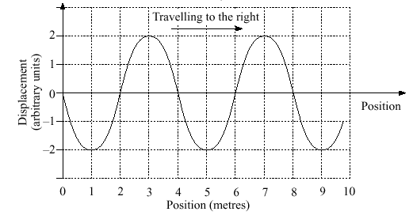

Displacement (metres)

1. What is the amplitude of the wave? _____________ (1)
2. What is the wavelength of the wave? ____________ (1)
3. Calculate the frequency of the wave. (2)

1. Calculate the period of the wave. (1)

e) Using an arrow on the diagram above, show the direction of movement of the water’s surface at the

2m position. (1)

1. (7 marks)

A Sound wave passes through a thick concrete wall as shown below.

1. Complete the diagram showing the path of the sound through the concrete and out the other side. Show the wave fronts. (4 marks)

**AIR CONCRETE AIR**

1. State what happens to the velocity, frequency and wavelength of the sound wave above by using the words ***increases***, ***decreases*** or ***remains the same*** as the ray passes from **air** into the **concrete**.

(3 marks)

Velocity __________________________________

Frequency ________________________________

Wavelength _______________________________

1. (3 marks)
2. A **closed pipe** is 50.0 cm long and is made to vibrate at its **first overtone**. Draw a

representation of the first overtone harmonic below. (1)

1. Calculate the frequency of the wave. (2)
2. Define resonance and state one example. (3)

Definition:

Example:

1. (3 marks)

a) What is the relationship between sound intensity and distance? (1)

b) If your ear experiences 1.20-12 Wm-2 of sound when you are 1.00m from a sound source, what will be the theoretical new sound intensity experienced by your ear when you are standing 4.00m from the same sound source? (2)

8. (6 marks)

A stationary car is observed at a set of traffic lights with its engine running. On the front of the car, an aerial is observed to be vibrating as shown in the diagram:

j0197897

(a) If the aerial is 0.800m long, calculate the wavelength of the standing wave. (2)

(b) The car’s engine idles at 1000 rpm. Assume that the aerial experiences 1000 vibrations per minute and calculate the speed of the wave in the aerial. (2)

(c) What could you do to the aerial so that the **tip** (end) of the aerial doesn’t vibrate? (2)

_________________________________________________________________________________________________________________________________________________________________________________________________________________________________________________

End of Test